Attention Athletes:
You must complete pages 11 & 14 – 17 of this handbook and return to your coach by Friday March 27, 2015. You may not participate after Friday, March 27th, 2015 until these forms are completed and turned into your coach.

By signing these forms and returning them to the athletic department, you are stating that you have read and understand all of the rules in this handbook.

Please remember that extracurricular activities are a privilege, not a right. Participants will be subject to athletic discipline policies for any on or off-campus violations of the code.

If you are on the roster of a team, you are required to be in attendance to all scheduled/ rescheduled athletic events. You may not pick and choose which events fit into your schedule. Please take this into consideration before joining a team.

A Message from the Athletic Department:

Welcome to the Muncie Burris/ Indiana Academy Athletics Program. We are excited that you have chosen to become a part of the Burris sports family. You are privileged to participate in a first class athletic program. Muncie Burris/ Indiana Academy athletes have additional responsibilities. You will be held to a higher standard, you will be in the public eye, and you should never do anything that will embarrass yourself, your team, your school, or your family.
We take the term “student athlete” very seriously here at Burris & the Indiana Academy. You are expected to do your best not only in the athletic arena, but the classroom as well. We have a very supportive faculty, and they will be more than willing to assist you if the need arises. However, it is your responsibility to put forth your best effort in the classroom just as you do in the sports programs you participate in.
The experiences you gain from your athletic involvement will carry over into all aspects of your life. Perseverance, commitment, determination, and teamwork are all essential qualities for your success in today’s world.

Continue to work hard, and when you lay your head down at the end of the day, make sure you can say you gave your best effort. We hope your 2014-2015 school year is all you hoped for; only you can make that happen!

Sincerely,

Burris & the Indiana Academy Athletic Department

Conference: Muncie Burris/ Indiana Academy will operate as an Independent School for the 2014 – 2015 school year.

Attendance: If you have an unexcused absence on the day of an event, you may not participate that evening. Once you accumulate 5 tardies, you will be required to meet with the athletic director to discuss the situation. Upon the 10th tardy, you will be suspended from the next athletic event. Past 10 tardies, for every 5th tardy you will be suspended for an athletic event.

Team Loyalty: When you become a member of a team, you have a responsibility to your fellow teammates. It takes all members for a team to be successful. If for any reason you are unhappy being a member of the team, you are to discuss your feelings with the coach. If you choose to quit/ walk off without notifying your coach, you may be ineligible to participate in future activities. You must have a release from your coach to leave the team and join another organization during the same season.

Appropriate Concerns to Discuss with Coaches:
-The development of your child, mentally and physically
-Ways to help your child improve
-Concerns about your child’s behavior

It is very difficult to accept your child not playing as much as you may hope. However, coaches make judgment calls based on what they believe is best for the team. As you have seen from the list above, particular things can and should be discussed. However, the list below contains things that must be left to the discretion of the coach.

Issues Not Appropriate to Discuss with Coaches:
-Team Strategy
-Play calling
-Other student-athletes

There are situations that may require a coach/ parent conference. These are to be encouraged. It is essential both parties involved have a clear understanding of the others position. When these conferences are necessary, the following procedure should be followed to help promote a resolution to the situation.

-Call to set up an appointment with the coach.
-If the coach cannot be reached, call the Athletic Director. He will pursue setting up a meeting for you.
-At no time should a meeting between parent and coach to discuss a concern be initiated on the same day as the event.
-DO NOT ATTEMPT TO CONFRONT A COACH BEFORE OR AFTER A CONTEST/ PRACTICE.

Expectations for Student-Athletes:

HIGH SCHOOL-
-In order to be considered eligible to participate in interscholastic athletics, the following Indiana High School Athletic Association rules must be met: The student must have earned passing grades in at least five full credit subjects prior to the season, during each grading period, through to the completion of the athletic season. A course in which the student previously received a passing grade and which is currently being retaken, or retaken in the prior grading period, does not count toward one of the five credits required. In addition, effective with the class of 2018, all athletes must maintain a 2.0 cumulative G.P.A. Students with special needs may petition to the Athletic Director & Principal for an eligibility waiver on a case by case basis. Grades are posted on grade cards on the Wednesday following the Friday end of the grading period. This allows a three-day grace period for the student to make up any work not done during the 9-week period. The grade that goes onto the report card IS THE GRADE THAT DETERMINES ELIGIBILITY FOR THE NEXT GRADING PERIOD. THIS GRADE WILL NOT BE CHANGED AFTER THE THREE-DAY GRACE PERIOD FOR PURPOSES OF ELIGIBILITY.

MIDDLE SCHOOL-
To be eligible to participate in any athletic contest, you must be passing ALL subjects by Friday at 3pm in order to participate the following week. Grades will be checked every Friday at the end of the day, and parents will be notified on Friday or as soon as possible.

Definition of Failing Grades:
-Indiana Academy: 0, NC, D* are all considered failing grades for all eligibility and/or transfer purposes.

-Muncie Burris: 0, NC, F are all considered failing grades for all eligibility and/or transfer purposes.

Behavior in School: Student-athletes are to be on their best behavior at all times. Referrals, which show the student is defiant, disrespectful, or unmotivated, could result in the athlete being suspended for a period of time or removed from the team.

Behavior at an Event:

Ejection- Any student-athlete/ coach ejected will have to meet with the Principal and the Athletic Director to decide the length of suspension that will accompany the ejection from the event. IHSAA rules require one event; Burris rules will require a minimum of 1 additional event.

Technical Fouls/Yellow cards will be up to the discretion of the Athletic Director and Coach.

Profanity- This will not be tolerated at all. Students, coaches, or sponsors for any reason should not use profanity. Use of profanity by any, carries a stiff penalty.

Arguing- Student will not argue with any official during the competition. The student is there to compete, and the official is there to officiate.

Leaving the Bench- Any student who leaves the bench area during any type of altercation will meet with the Principal and Athletic Director to discuss punishment.
Uniforms: Student-athletes are expected to wear their uniforms in the appropriate way. Undergarments hanging out and sagging will not be tolerated. In basketball, all competitors must wear socks that rest above their ankle. All administrators and coaches have been advised to deal with this during events.

Alcohol/ Drug/ Tobacco Policy: First offense: The athlete will be suspended for 25% of the season, which may carry over to the following sports season. Second offense: The athlete will be suspended for 50% of the season, which may carry over to the following sports season. Third offense: The athlete will be suspended for 365 days beginning from the day of their offense.

Academy Extended Weekends: If an event falls over an extended weekend, Academy students are expected to be present. Missing an event will result in a one game suspension. However, if only practice is scheduled to take place over an extended weekend, the student-athlete will not be punished for missing practice.

Sports We Offer:
Fall- Boys Tennis, Cross Country, Boys & Girls Soccer, and Girls Volleyball
Winter- Boys & Girls Basketball, Boys & Girls Swimming and Cheerleading
Spring- Golf, Boys & Girls Track, Girls Tennis, and Baseball

Please remember, all student athletes must have the following turned in, in order to participate:

-An IHSAA physical dated after April 1, 2014
-Handbook agreement
-Concussion forms
-Sudden Cardiac Arrest
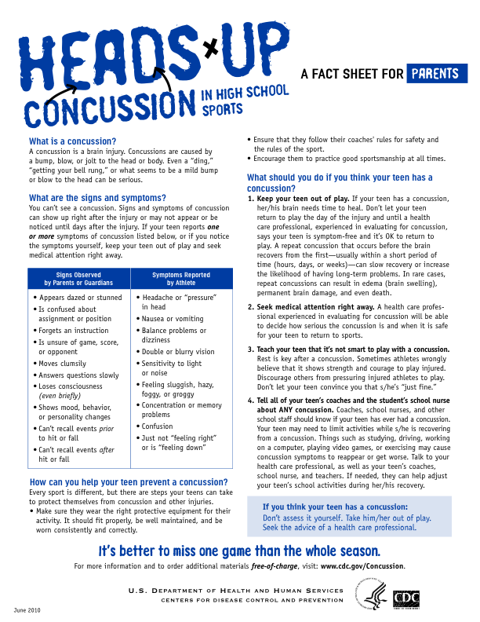
-Emergency Information Sheet
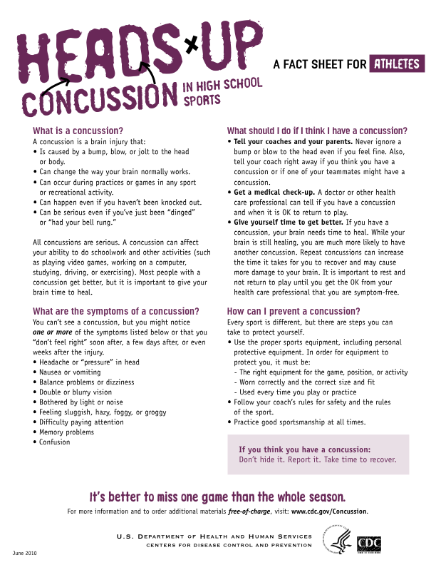
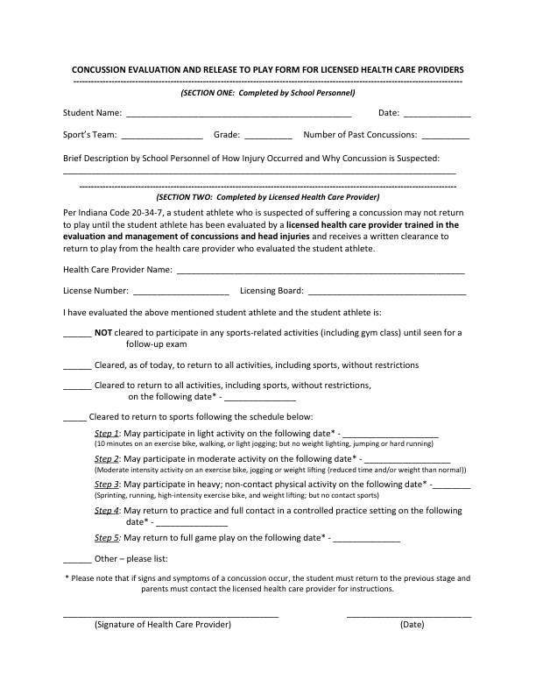
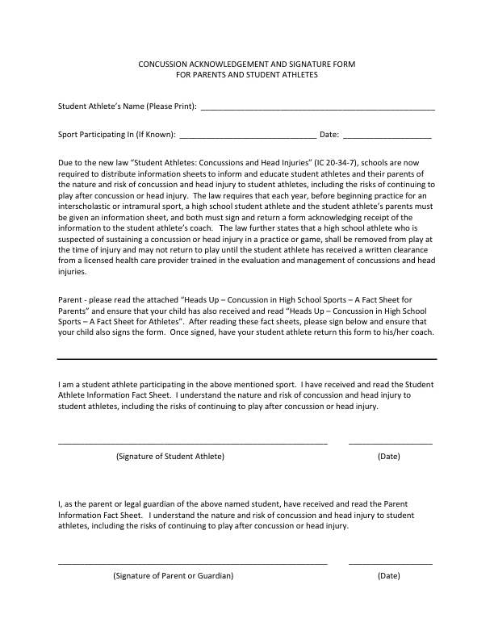
Sudden Cardiac Arrest Information

Sudden Cardiac Arrest (SCA) is when the heart abruptly and unexpectedly stops beating, resulting in no blood flow to the brain and other vital organs. To understand SCA, it helps to understand how the heart works. The heart has an electrical system that controls the rate and rhythm of the heartbeat. Problems with the heart’s electrical system can cause irregular heartbeats called arrhythmias (ah-RITH-me-ahs). There are many types of arrhythmias. During an arrhythmia, the heart can beat too fast, too slow, or with an irregular rhythm. Some arrhythmias can cause the heart to stop pumping blood to the body-these arrhythmias cause SCA.
Sudden Cardiac Arrest is NOT a Heart Attack. A heart attack may cause SCA, but they are not the same thing. A heart attack, also called a myocardial infarction (MI), is caused by a blockage that stops the blood flow to the heart and causes damage to the heart muscle. SCA is a malfunction in the heart’s electrical system, causing the heart to suddenly stop beating.
How common is SCA? The Center for Disease Control and Prevention estimate that every year approximately 300,000 out of hospital cardiac arrest occur in the United States, and about 2,000 patients under age 25 die of SCA.
Signs and Symptoms: Although SCA happens unexpectedly, signs and symptoms may include one or more of the following:
- Dizziness or light-headedness Fainting (syncope)
- Fatigue Weakness
- Nausea Vomiting
- Fainting Chest Pains
- Difficulty Breathing ABNORMAL racing heart or
Palpitations
If an athlete experiences any of these symptoms, he/she is to be immediately removed from participation. The athletic trainer will perform an on-site assessment and refer athlete to his/her primary care physician. The evaluating physician must provide written clearance for the athlete to return to play. If the athlete is referred to a cardiologist, the cardiologist must provide written clearance for return to play. The cardiologist also has the final say in any return to play decision.
Risks of continuing to play or practice after experiencing one or more symptoms of SCA. When the heart stops, oxygenated blood stops flowing to the brain and other vital organs. Death or permanent brain damage can occur in only a few minutes. Most people who have SCA die from it – often within minutes.
Collapse: SCA should be suspected in any athlete who has collapsed and is unresponsive. Airway, breathing, and circulation should be assessed. Heart rhythm should be assessed using an Automated External Defibrillator (AED), a device that sends an electric shock-if needed to the heart to try to restore normal heart rhythm.
Early detection, prompt CPR, rapid activation of Emergency medical Services, and early defibrillation are vital to the athlete’s survival. For any athlete who has collapsed and is unresponsive, an AED should be applied as soon as possible for rhythm analysis and defibrillation if indicated. The greatest factor affecting survival after SCA is the time from arrest to defibrillation.
In an athlete who has collapsed in the absence of trauma, suspicion for sudden cardiac arrest should be high until normal airway, breathing and circulation are confirmed. Agonal respiration or occasional gasping should not be mistaken for normal breathing ans should be recognized as a sign of SCA; myoclonic jerking or seizure-like activity shortly after collapse should be treated as SCA until proven otherwise. If no pulse is palpable, the patient should be treated for SCA, and CPR should be initiated.
Can SCA be prevented? Pre-participation screening is one strategy available to prevent SCD, but the best protocol to screen athletes is highly debated, and some methods lack accuracy. As many as 80% of patients with SCA are asymptomatic until sudden cardiac arrest occurs. In 2007, the American Heart Association released a helpful 12-point pre-participation cardiovascular screen for competitive athletes based on the medical history and physical examination.
12-Element AHA Recommendations for Pre-participation Cardiovascular Screening of Competitive Athletes:
Medical/Personal History
- Exertional chest pain/discomfort
- Unexplained syncope/near-syncope
- Excessive exertional and unexplained dyspnea/fatigue, associated with exercise
- Prior recognition of a heart murmur
- Elevated systemic blood pressure
Family History:
- Premature death (sudden and unexplained, or otherwise) before age 50 years due to heart disease, in 1 or more relatives.
- Disability from heart disease in a close relative less than 50 years of age
- Specific knowledge of certain cardiac conditions in family members: hypertrophic or dilated cardiomyopathy, long-QT syndrome or other ion channelopathies. Marafan syndrome, or clinically important arrhythmias
Physical Examination
- Heart murmur
- Femoral pulses to exclude aortic coarction
- Physical stigmata of Marafan syndrome
- Brachial artery blood pressure (sitting position)

When should a student athlete see a heart specialist/cardiologist?: Upon examination the primary care provider will provide the referral to the pediatric cardiologist.

Please keep at home for your information and return the acknowledgement form to your coach or athletic director on the first day of practice.

As a student athlete who participates in athletics and as the legal parent/guardian, I have read the information material provided by Burris Laboratory School related to Sudden Cardiac Arrest that may occur during participation in athletic programs and understand the content and warnings/

Student Athlete Signature: ___________________________________________

Student Athlete Name Printed: _______________________________________

Date:_________________________

Parent/Guardian Signature: _________________________________________

Parent/Guardian Printed:___________________________________________

Date:__________________________

MUNCIE BURRIS/INDIANA ACADEMY HIGH SCHOOL
ATHLETE EMERGENCY MEDICAL INFORMATION

Student’s Name: ______________________________________ Birth Date: ______________________
Address: ____________________________________________ Home Phone #: _________________
Parent/Guardian:
Parent(s) (relation): ___________________________________ Work Phone #: __________________
_____________________________________ Cell Phone #: ___________________
Name of relative, close friend, or neighbor to be contacted if parents cannot be located:
Name (relation): _____________________________________ Phone #: _______________________
Family Physician: ____________________________________ Phone #: _______________________
Family Dentist: ______________________________________ Phone #: _______________________
Family Optometrist: __________________________________ Phone #: _______________________
Health Alert (diabetic, allergies, medication allergy, asthma, etc.): _______________________________
Medicine(s) Presently Taking: ____________________________________________________________
Hospital Preference: ____________________________________________________________________
Primary Insurance Company: _____________________________________________________________
Phone: ______________________ Policy Holder’s Name: ____________________________________
ID Number: _________________________ Group Number: ____________________________________
SPORTS:____________________________________________________________________
In the event that an emergency arises during a practice session or a game, an effort will be made to contact the parents or guardians as soon as possible. If the parents or guardians cannot be reached, permission is hereby granted to the attending physician to proceed with any emergency medical or minor surgical treatments, x-ray examination, and immunizations for this athlete. In the event of serious illness, significant injury, or the need for major surgery, the attending physician will attempt to contact the parents or relatives. If the physician is not able to communicate with the parents or relatives, the treatment necessary for the best interest of this athlete may be given. Permission is also granted to the coach or athletic trainer to provide the needed emergency treatment to the athlete prior to admission to the medical facilities.
_____________________________________________________________________________________
Parent/Guardian Signature Date Student Signature Date
By signing these forms and returning them to the athletic department, you are stating that you have read and understand all of the rules in this handbook.

Participant: By signing this paper, you acknowledge that you have READ AND UNDERSTAND the rules. You are agreeing to abide by the rules set forth in the manual in order to be, and remain, a part of the Burris/ Indiana Academy Athletic Program.

Parent: As a parent, agree to help have your student-athlete to adhere to the regulations of the athletic program in order to be and remain a part here at Burris/ Indiana Academy.

Athlete ___________________________________________________________________

Parent/ Guardian _______________________________________________________

Date ______________________________

Sport______________________________

ATHLETIC INFORMATION

NAME: ________________________________________________ AGE: ______
ADDRESS: ________________________________________________________________
**home address for academy athletes
TOWN AND ZIP: ________________________________________________________________
PHONE (home) ________________________ GRADE: ____
BIRTHDATE: _____/______/___________

PARENT/GUARDIAN NAMES:______________________________________________________
Email: _________________________________________________________________________________
WORK PLACE: _______________________________________________________________________

SPORT: ________________________
VARSITY LETTERS YOU HAVE EARNED: __________
IN WHAT SPORTS: ____________________________________

EMERGENCY PHONE NUMBERS:
DAY:__________________________________ cell:________________________
NIGHT:_________________________________
FAMILY DOCTOR:_________________________________________

